MY SAILS 1
Unit 4: MEET MY FAMILY

Stran 63, Naloga 15
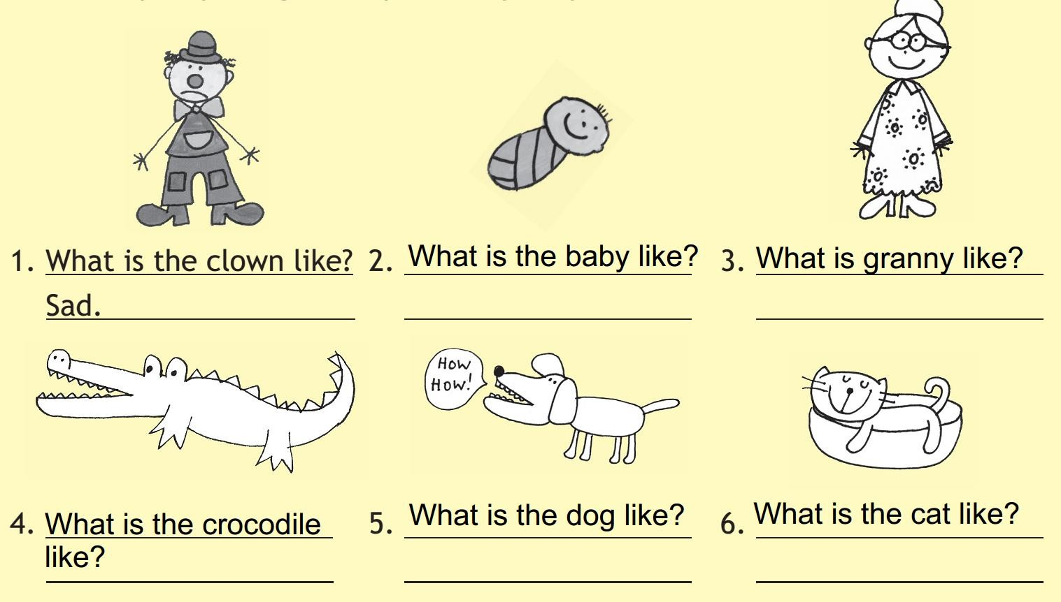

Možne rešitve:

2. Happy.

3. Nice.

4. Dangerous.

5. Loud.

6. Lazy.

Stran 64, Naloga 16a

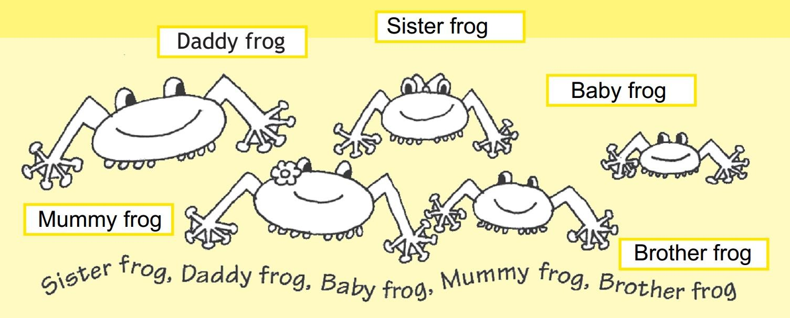

Stran 65, Naloga 17

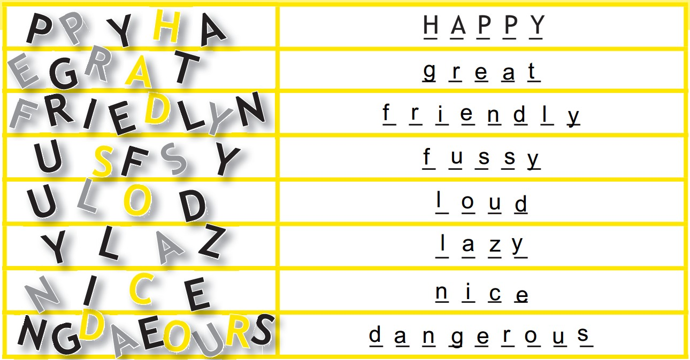

Stran 65, Naloga 18

