FRUIT
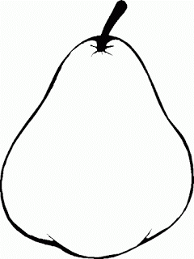
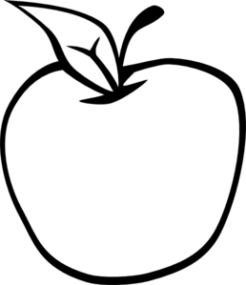

AN APPLE IS GREEN. A PEAR IS YELLOW.
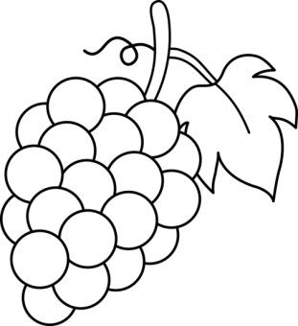
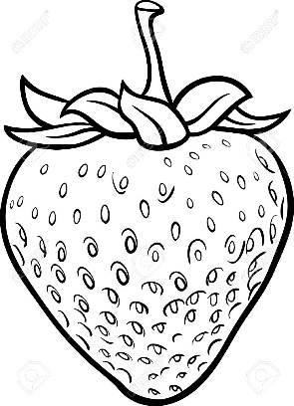

A STRAWBERRY IS RED. GRAPES ARE PURPLE.
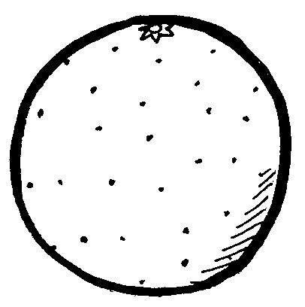

A BANANA IS YELLOW. AN ORANGE IS ORANGE.

