18.5. – 22.5. – 2. in 5. skupina – 8.razred – 9. TEDEN
Pozdravljeni. Ker se bliža čas ustnega ocenjevanja, boste ta teden ponavljali in utrjevali snov za nazaj.
1) Past Simple
0. He worked (work) hard.
1. I saw (see) you.
2. My parents went (go) to Moscow.
3. Did he visit (visit) his friends?
4. They didn’t stay (not stay) in a hotel.
5. What did my dog eat (eat)?

2) Spodnji opis dopolni z glagoli iz oklepajev. Glagole postavi v PAST CONTINUOUS TENSE.
0. She was drinking (drink) juice early in the morning.
1.My brother and sister were playing (play) tennis at11a.m. yesterday.
2. Were you still working (work) at 7pm last night?
3. At 8.30am today I was driving (drive) to work.
4. We weren’t sleeping (not sleep) at 11pm.
5. Why was he having (have) lunch at 4pm?
6. John was shopping (shop).
7. Mary wasn’t waiting (not wait) for me.
8. Was he having (have) a shower?
9. I wasn’t reading (not read).
10. My friends were watching (watch) TV.

3) Za vsako sliko napišite, kaj se na njej dogaja in pri tem uporabite The Past Continuous tense.
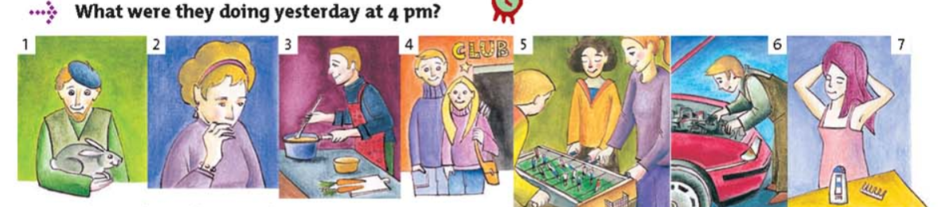
1. He was holding a rabbit. 2. She was biting her nails.
3. He was cooking. 4. They were going out.
5. They were playing table football.
6. He was repairing his car. 7. She was washing her hair.

4) Odgovorite na naslednja vprašanja o besedilu What on earth were you doing there?

1. In Cornwall. They are on holiday in Cornwall.
2. They spent the afternoon in Penzance. \ They were cycling in Penzance. \ It was exciting.
3. They saw Robbie Williams.
4. He was making a pop video.
5. A horse and an eagle.
6. They were cycling along (when they suddenly saw him).
7. No, he didn’t. He came out of an empty warehouse.
8. Yes, there were. Lots of people were watching.
9. They were cheering.
10. He came to Laura and spoke to her but she couldn’t say a word.
11. They needed two children for a scene and they chose them.

5) Pozorno preberi besedilo in vstavi ustrezne oblike glagolov za Past Simple ali Past Continuous.
Last night Mr. and Mrs. Rojas stayed (stay) home. It was (be) cold and rainy and they didn’t want (not want) to go out in the bad weather. Mrs. Rojas was making (make) some popcorn and ice tea. At 8:00, Mr. and Mrs. Rojas went (go) into the living room, sat (sit) on the sofa, began (begin) the movie and ate (eat) and drnk (drink). At 8:15, Mr. and Mrs. Rojas realized they already watched the movie last year and they didn’t want (not want) to watch it again.
“Now what?” asked Mr. Rojas. “Let’s play cards!” answered Mrs. Rojas. At 8:30 Mr. and Mrs. Rojas started (start) to play cards. They were playing (play) for about 10 minutes when Mr. Rojas looked (look) out the window. The rain changed to snow and the trees were covered in beautiful white snowflakes. “I’m bored. Let’s play some music and dance.” said Mrs. Rojas. Mr. Rojas was surprised. “Dance? But I really don’t ….” “Oh come on!” Mrs. Rojas insisted. She put (put) on a romantic CD and they both started to dance. They were dancing (dance) for about 1 minute when suddenly the music stopped (stop) and the lights went out. Mrs. Rojas laughed. “We’re just not very lucky tonight, are we?” she said. Mr. Rojas said, “Of course we’re lucky! We are together!” He kissed her and continued to dance with her, in the dark and without music.

6) Obnovite zgodbo o Ms Cross ali odgovorite na naslednja vprašanja:
- It was Saturday morning.
- It was warm and the sun was shining.
- She was lying in her bed.
- A strange voice asked: »Is this Dr Brisk’s hospital?”
- A stranger asked her: “Can you tell me the shortest way to DR Brisk’s hospital?”
- No, she didn’t.
- She met her friend Rosy there.
- They were talking about good old days.
- The waiter spilled a cup of hot coffee on her dress and burnt her arm.
- The shoe’s heel came off.
- The man bumped into her.
- Because he was carrying a lot of boxes and bags and couldn’t see her.
- He telephoned for an ambulance.
- The ambulance took her to Dr Brisk’s hospital.
- She knows the shortest way to Dr Brisk’s hospital.

7) Obnovite zgodbo o Solidays ali odgovorite na spodnja vprašanja:
- Soliday festival lasted for three days.
- Luc Barruet is a festival organizer.
- He is 37 years old.
- Luc founded a charity organization in 1992.
- The organization fights against Aids.
- No, he doesn’t.
- No, he isn’t.
- It all began at the Sorbonne in early 1990s.
- When he was studying one of his friends got Aids.
- He decided to mobilize young people in a fight against this illness.
- He managed to persuade some celebrities to come to the festival.
- Yes, they did.
- He organized the first Solidays festival in 1999.
- More than 150 artist came.
- They met and recorded a Solidays album.
- It contained 14 titles.
- Luc sent money to Africa.
- He sang “Under African Skies”.
- Fans were cheering, screaming and some were near to tears.
- Avril Lavigne came on stage.

Zvezek z odgovori slikajte ter prilepite k anketi. Tokrat je bilo dela več, a le zato, da boste temeljito ponovili in utrdili znanje, ki je potrebno za ustno ocenjevanje znanja.
Želiva vam uspešno delo,
učiteljici Mateja Novak in Albina Hribar

