MY SAILS 1
Unit 5: HOME

stran 76, naloga 8a (izbirna)

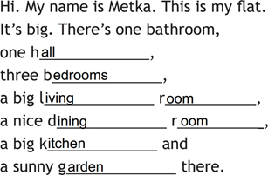

stran 78, naloga 10a
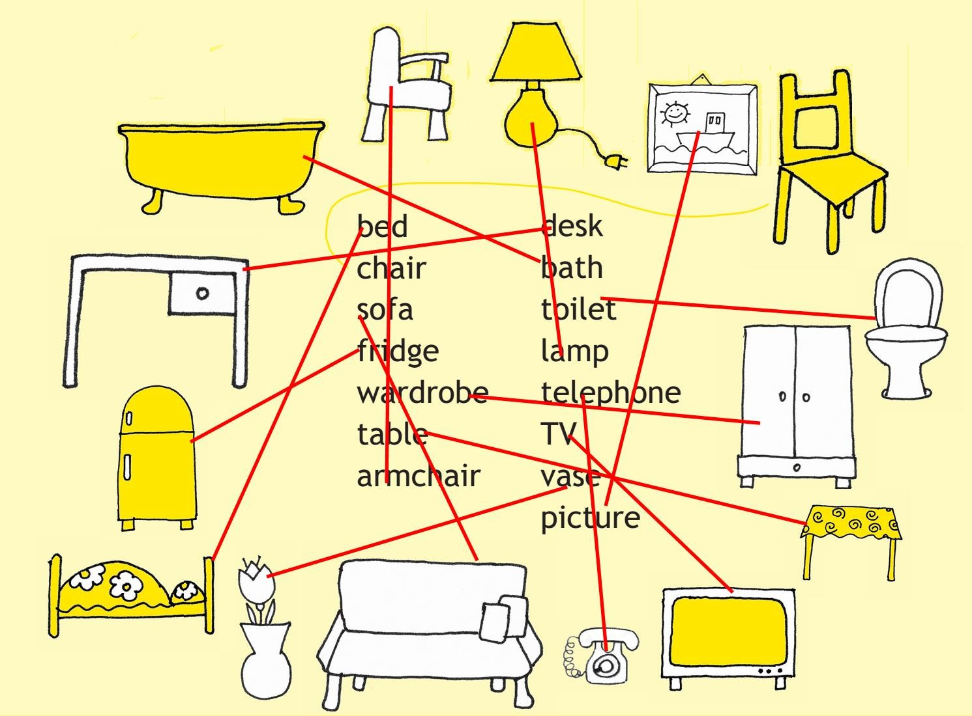

stran 78, naloga 10b

carpet, cooker, shelf, bed, mirror, dishwasher, washing machine, door, washbasin, toilet, window, cupboard

stran 78, naloga 10c
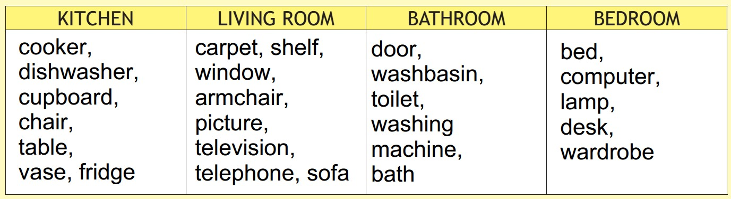

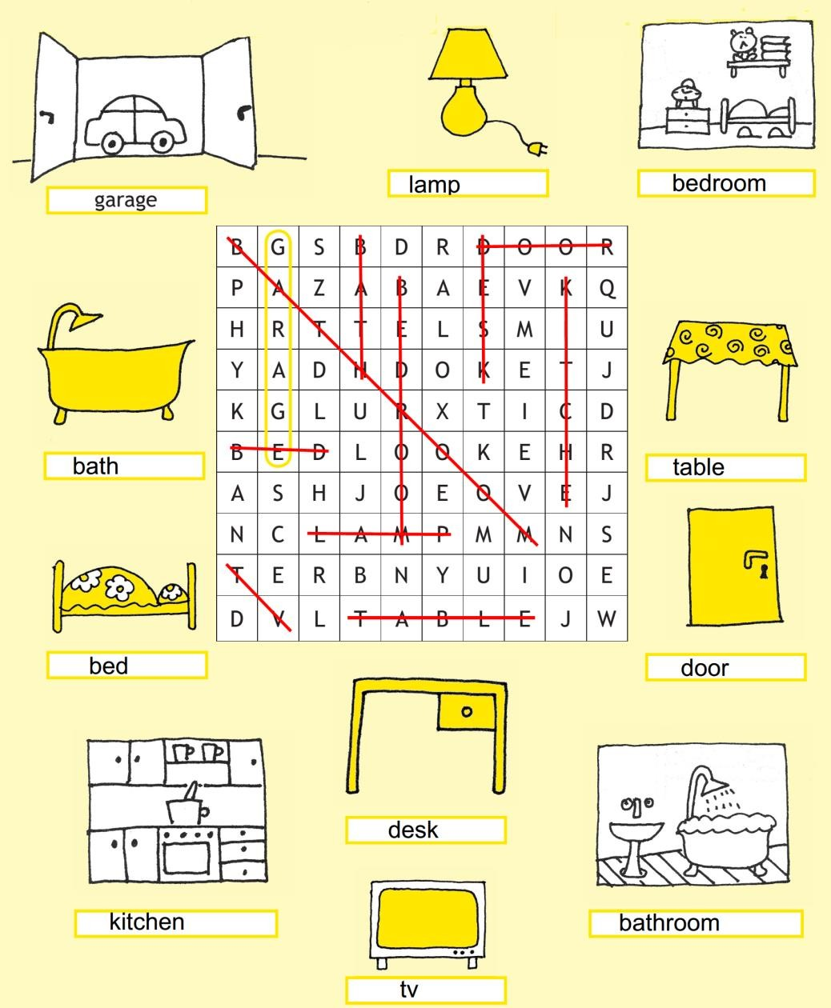
stran 79, naloga 11

stran 80, naloga 12
