MY SAILS 1
Unit 5: HOME

Stran 72, Naloga 1

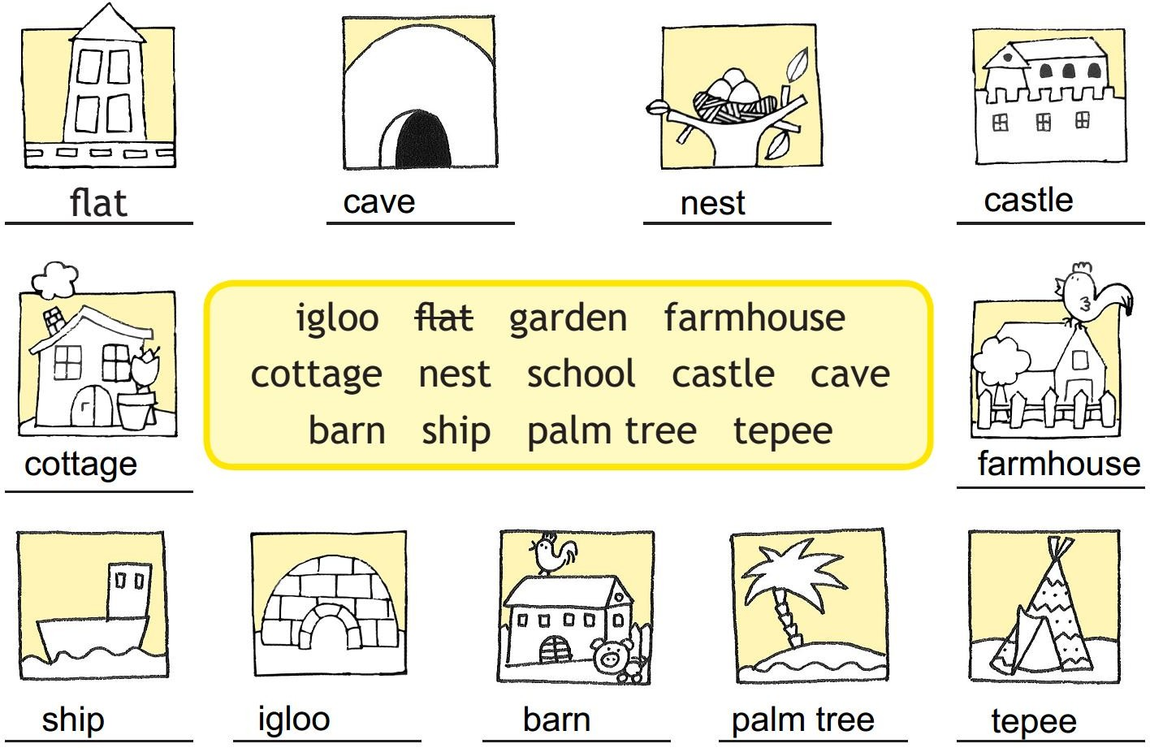

Stran 72, Naloga 2

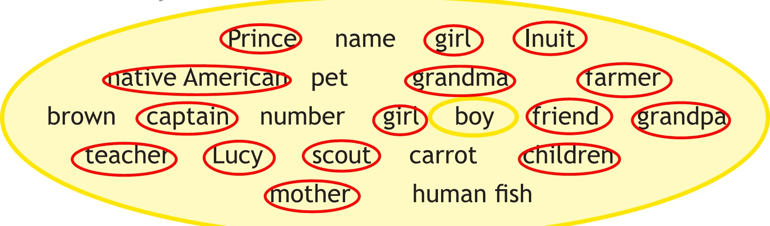

Stran 73, Naloga 3a
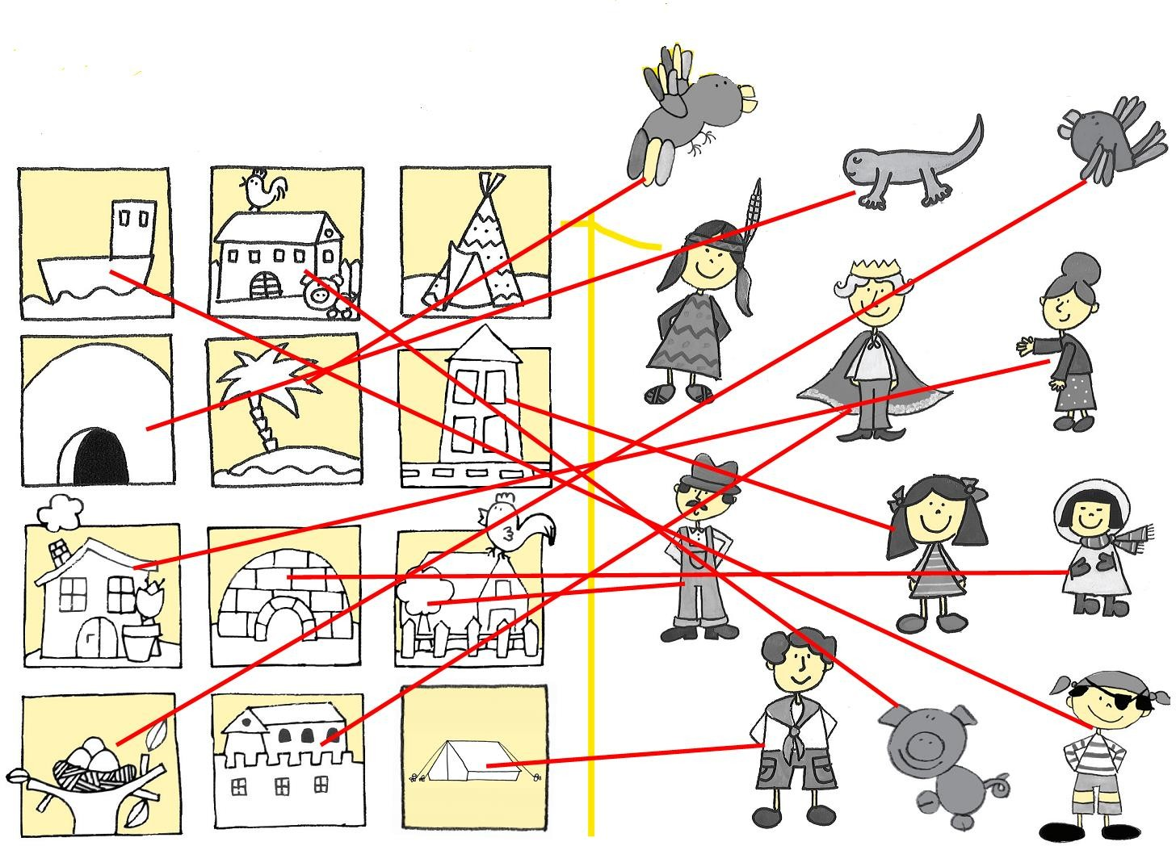

Stran 73, Naloga 3b

house – girl, igloo – Inuit, farmhouse – farmer, cottage – grandma,
nest – bird, castle – prince, cave – human fish, barn – cow,
tent – scout, tepee – native American, boat – captain, palm tree – parrot

